

Value
Insight

ORDER FORM

Please complete and email or post this order form to: Community/Value Insight
Post: HACT 49-51 East Road, London N1 6AH
Scan and Email: marcelle.dopwell@hact.org.uk

A joint Value and Community Insight invoice will be sent to the organisation address specified below.
Contact name
Job Title
Organisation
Address
Telephone number
Email
Purchase Order No. (if appl.)

Name of person to be set up as the initial Group Administrator
Contact name
Job Title
Email Address

1 year subscription (Value insight can only be purchased if you have or are purchasing Community Insight)
Item Description | Unit Price | Quantity | Value
Community Insight | £5,000.00 |  | £5,000.00
Value Insight | £3,500.00 |  | £3,500.00
 |  | VAT @ 20%
 |  | Total
◻ Please tick if your organisation operates an approved suppliers list that will need to include HACT before a Purchase Order is generated

Declaration
I have read and agree with the stated terms and conditions.
Signed: | Date:

Terms and conditions
- Except where indicated, the datasets provided by the Community and Value Insight tools and any accompanying documentation and materials together with all of the intellectual property rights (including copyright and trade marks) contained within it belong to Oxford Consultants for Social Inclusion (“OCSI”) and the Housing Associations’ Charitable Trust (“HACT”): ownership will not pass to you.
- The Wellbeing Values contained within Value Insight are the ownership of HACT and Daniel Fujiwara and are subject to Licencing Conditions – see www.hact.org.uk/social-value-bank-licencing-information/
- Community and Value Insight are yearly subscription. Subscribers will be notified of their renewal two months before end of subscription; and subsequent reminders at monthly intervals. If subscription is more than 28 days overdue, account access will be suspended; after 56 days all data will be deleted.
- Data accessed through The Insight tools are always up to date. Our aim is to ensure that all datasets are updated within 2-3 days and no more than a week from their release. Data accessed through The Insight tools are always referenced and dated, so you can be sure of its source and date.
- The Insight tools are constantly under development and a range of additional features will be added to the service in the coming year. New features will usually be provided to all users at no additional charge as part of their annual subscription. However, HACT and OCSI reserve the right to charge for major additions to functionality. There is no obligation to purchase additional paid for functionality, and choosing not to pay will not affect your use of existing features in The Insight tools. In the event that additional functionality is made available for an additional charge, you will be notified accordingly.
- The Insight tools are an organisational purchase which cannot be used by other organisations. They are available to use by the whole organisation, and has no restriction on the number of users. However, reasonable usage applies.
- The dataset includes data and information developed by third parties of which OCSI and HACT is not able to control or verify the accuracy. OCSI and HACT agree to use reasonable care and skill in the collection and collation and statistical modelling and presentation of the data and information. Data and information are provided on an “as is” basis and we give no representations or warranties about the accuracy, completeness, satisfactory quality or fitness for any particular purpose of the same.
- The data and information does not constitute advice and should not be used as the sole basis for any business decision, and OCSI and HACT shall not be liable for any decisions taken on the basis of the same. OCSI and HACT’s liability for any losses suffered as a result of any breach of contract or negligence is strictly limited to the price paid for the Community and Value insight service OCSI and HACT provide and any losses which are a foreseeable consequence thereof. Losses are foreseeable where they could be contemplated by you and OCSI and HACT at the time your order is accepted by us.
- Subscribers have the right to use and reproduce all exported maps, tables and data. If being used for external purposes (such as reports, websites, publications), The Insight tools should be attributed as the source, alongside originating data sources. The reference should include the phrase “Data provided by Community Insight http://www.communityinsight.org …” or “Data provided by Value Insight http://www.valueinsight.org …”
- Data protection: housing provider information provided will be held on a databases administered by HACT and OCSI. We will not disclose your information to any other organisations. All data is kept securely and will not be sold, passed to other organisations or used for purposes other than with the explicit consent of the subscriber.
- Cancellation policy: all cancellations must be made in writing either by email or post (details below). You have 14 days to cancel your booking. If cancelled within 14 days you will receive a full refund. After 14 days refunds cannot be offered.
- HACT and OCSI can terminate the service with one month’s notice. In such cases, a refund will be offered of a sum proportionate to the share of the remaining months of subscription.
- Subscribers can cancel their subscription with immediate effect (closing the account). No data will be held longer than 28 days after closure of account. No refund on the subscription will be paid.
- These terms and conditions are available on the Community Insight website http://www.communityinsight.org/legal/ and http://www.valueinsight.org/legal/ and may be updated from time to time. You will be notified by email if any changes are made to the terms and conditions under which the service is provided.


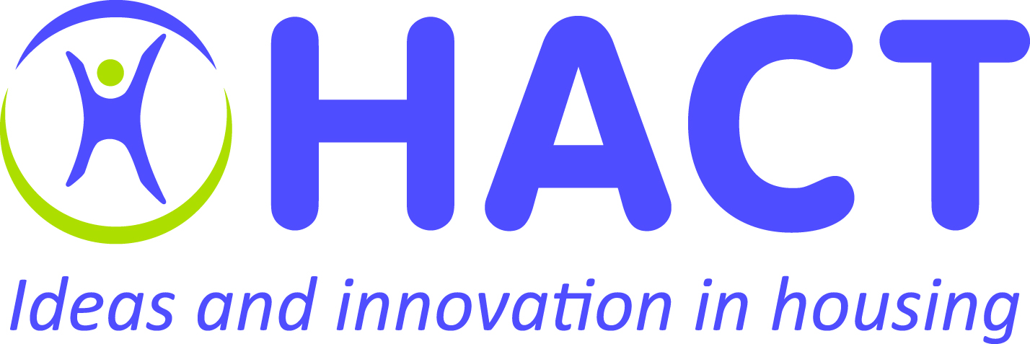

www.communityinsight.org www.valueinsight.org

Community and Value Insight are jointly owned and developed by HACT and OCSI.
HACT is registered as the Housing Associations' Charitable Trust, charity number 1096829, Company number 04560091
HACT, 49-51 East Road, London N1 6AH
Tel: 020 7250 8500 Web: www.hact.org.uk Email: info@hact.org.uk

